# Mount Maunganui Flying Site: Mauao

## General info:

Ownership: Mauao historic reserve is owned by local iwi Ngai Te Rangi, Ngati Ranginui and Ngati Pukenga in the form of the Mauao Trust. The reserve is managed jointly by the Mauao Trust and Tauranga City Council under the direction of the Ngā Poutiriao ō Mauao (Mauao Joint Administration Board).

Paragliding and Hang gliding off Mauao is a privilege, not a right. Pilots must adhere to the site rules and fly respectfully.

Elevation: 232m(761ft)

Airspace: General Aviation Area up to 1500ft

Visitors: visiting pilots (non BOPHGPG club-members) must complete the visiting pilot form on the club website, have this accepted, and once accepted, undertake a site briefing prior to flying. Please provide plenty of notice to have the form verified. We are a volunteer organisation and do not monitor the website 24/7.

Overseas visiting pilots please ensure you are a member of NZHGPA and have completed the requirements specific to flying Mauao <http://www.nzhgpa.org.nz/visiting-pilots> prior to completing the BOPHGPA club visiting pilot form.

Bay of Plenty Facebook <https://www.facebook.com/BOPHangGlidingParagliding/>

Weather Check :Harbour conditions is updated every 3 minutes. Please check date and time stamp in bottom right corner to ensure you are reading current conditions <http://www.port-tauranga.co.nz/cargo-and-shipping/harbour-conditions/>

Windfinder https://www.windfinder.com/forecast/mount_maunganui

Skills: The launch sites on the Mount are often in turbulence. Launching requires good ground handling skills and experience with turbulent conditions on take-off.

## Mauao Safety Protocols:

* Pilots must be briefed prior to launch and abide by all NZHGPA rules and licencing requirements.
* Ensure all equipment is of required standard and warrant is current.
* Launch Sites • **Care must be taken to ensure public safety at all times** • Pilots must set up equipment off public walkways and ensure space is provided for safe passing •
* Pilots must ensure safe, controlled launch informing public of the line of launch and ensure public is at a safe distance at all times
* Pilot has assesed their flight plan poses no risk or nuisance to the public
* Pilot must determine by pre-flight inspection that the aircraft is in condition for safe flight

During flight

* Maintain a safe distance from the ground and public walkways at all times
* Fly within your ability, never endangering the public
* All pilots during site briefing must fully understand right of way rules
* No person shall operate a hang glider or paraglider in a careless manner so as to endanger people or property •
* Back protection / harness combination must be fit for purpose, used as specifically designed and intended by the manufacturer without any modifications and as presented for certification testing
* Helmet must conform to standard • Reserve parachutes are recommended for all flights

Landing

* Pilot must ensure landing area is clear •
* Pilots must ensure they set up early for landing and are in full control throughout landing
* **Pilots must ensure the safety of the public at all times during landing**
* Landing is restricted to the beach itself. No landing on the grass areas is allowed. Flying, including landing approaches are not permitted over the campground, surfclub, Marine parade or any of the built up areas. Approaches shall always be made over the sand, staying on the seaward side of the Norfolk pines at all times.
* Mount main beach is landable all year round, however, please follow some simple rules: - Land as far away from people as possible.
* Flying east of Moturiki is not permitted as it puts you in controlled airspace.
* Civil Aviation Authority is active in our area so have your licence and wing warrant up to date and on you so you can present these.

Aerial View of the Mount - Oriented North

## Launching:

North face works NNW-NNE

East face works NE-SE

West face works WNW-SW. Note that the west face is PG3.

## Landing

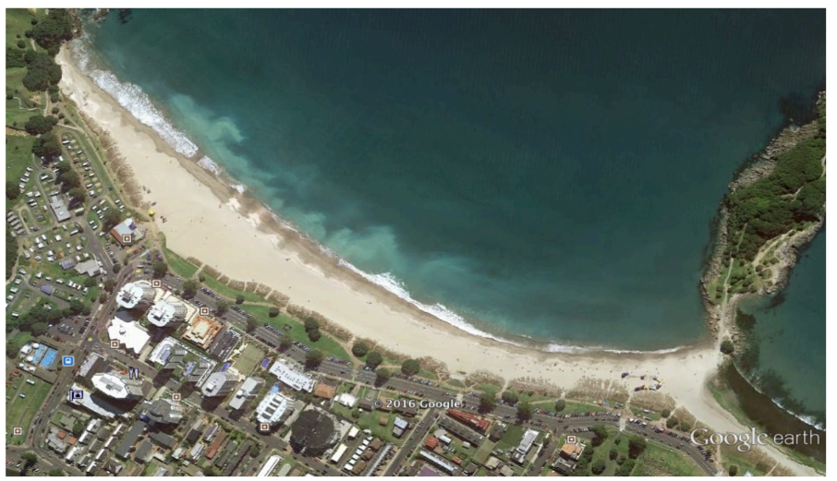

## South face

